About De Hub Haren

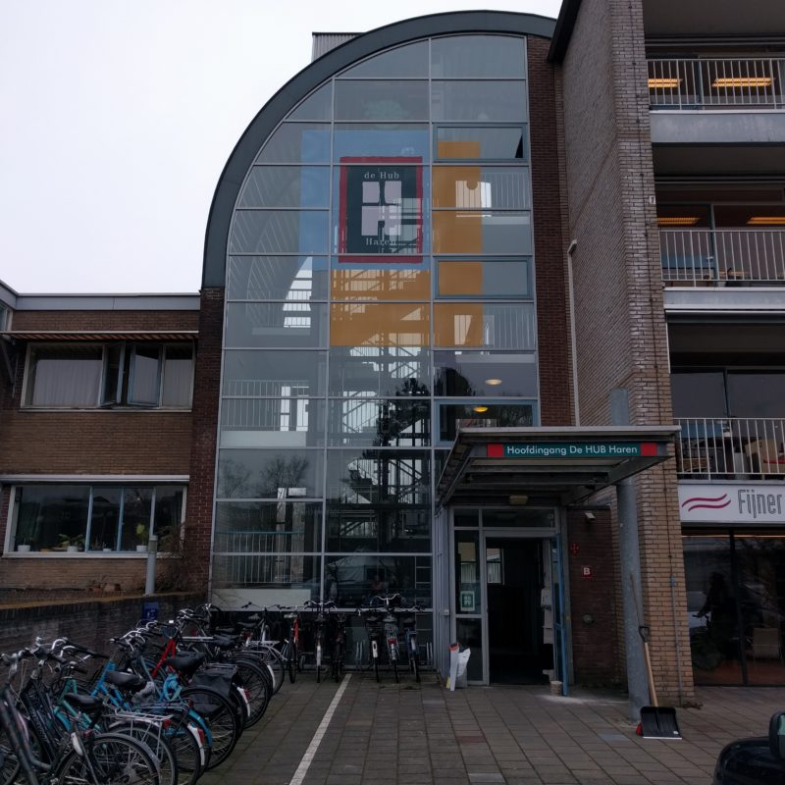

Its a former nurses home and later hospital for revalidation of childeren, both as part of revalidation centre Beatrixoord. Beatrixoord and also De Hub Haren is owned by UMCG.
The building of De Hub Haren had about 2018 no users and the UMCG had no plans what to do with this building.
A small health care organisation The Questcoach was looking for extra living for the youngsters which they offered care and cure for their mental health problems. Their director/owner started together with Carex, an organisation which builds houses in buildings en rent them, and an architect to make a plan to use this building. July of 2019 the first residents moved in, while the work for fixing living and work places continues. Nowaday their are about 55 residents and small companies. 15 of the residents are cliënts of the Questcoach; they get coaching in their daily life. All the others are a mix of status holders and Dutchmen. One of the companies offers coaching to jobs and coaching to integrate in the Dutch society. They invested in this room and kitchen and so they created a working place for status holders.
The policy of De Hub Haren is to offer a place where residents and companies work together. Since july of 2019 their originated relations between the residents spontaeneously. But because of measures for preventing corona their where now possibilities to organise meetings between the companies and the residents. That has to start these days.
The Hub Haren is a foundation whith a board and a supervisory board, of which I am a member. Beside I am a volunteer of one of the companies, the foundation Centre for self direction and participation. Experiences workers are volunteers for this company, working for their ideal to change offer targeted cure and care into demand targeted.
The Hub Haren gets no financial supply of the goverment. The local goverment has payed for the renovation of the building. And this debt is payed back in a period of 10 years from the proceeds of the rents.

Martinus Stollenga
Haren, 12 mei 2022.

