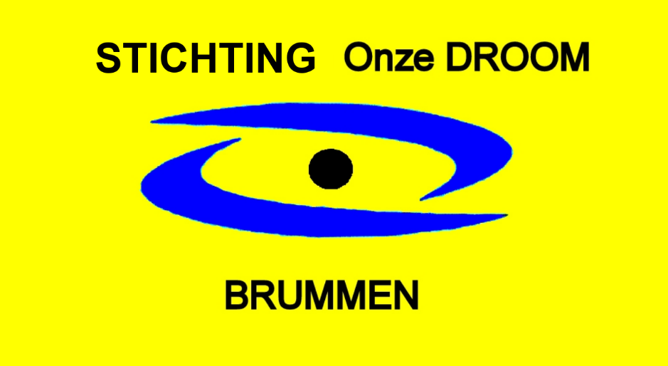

ANNUAL REPORT 2020-2021
OUR DREAM FOUNDATION

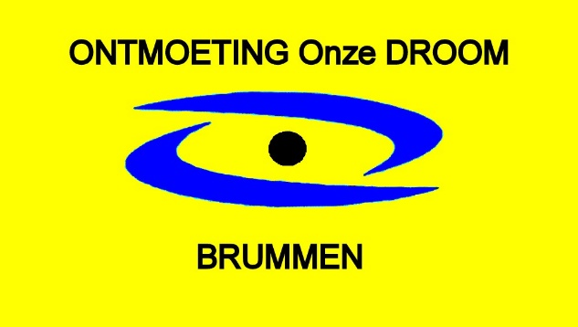

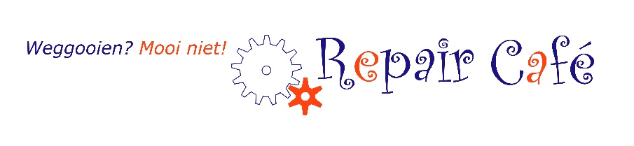

Clothing issue Brummen

Index

- Introduction 3
- 2020 own place with many new activities and wider opening hours 4
- 2021 open and closed, expansion of activities, a ribbon and farewell 8
- Internship and work experience places 10
- Circular activities in the context of sustainability 11
- Finance 12
- Cooperation partners 13
- Housing 15
- Poverty Reduction Activities 16
- Publicity 18
- Finally 19

1 INTRODUCTION

Our DROOM Foundation is a citizens' initiative with the aim of:
a. to promote social cohesion in the municipality of Brummen, by connecting young and old, by meeting each other, by being creative together, by eating together, as well as by offering a meeting, inspiration, daytime activity and learning workplace ;
b. promoting sustainability by, among other things, issuing clothing and reusing materials and repairing and restoring appliances and textiles (Repair Café Brummen)

Sonja Leemkuil is the initiator. Together with Carry Nijland and Marita Klein, she forms the board of the Onze DROOM Foundation. Since January 2016, the Onze DROOM Foundation has been organizing meeting activities. From 3 November 2016, Onze DROOM was housed in the rehearsal room of Harmonie Orkest Brummen at Meidoornlaan 18b in Brummen. The Repair Café Brummen was also housed here in 2017. On December 19, 2019, the board was able to collect the key to Meidoornlaan 18a Brummen at the counter in the town hall.

The past years were characterized by the gathering, meetings and activities from our own place Meidoornlaan 18a in Brummen.

Highs/Lows:
- The commissioning and opening of the new location Meidoornlaan 18a, the beautiful place and space to carry out our activities and our plan
- The construction of the garden
- Meeting activities, having lunch together, arranging flowers, being creative and listening to music
- expansion of activities, such as the knitting/crochet club, sports together, poverty alleviation
- Repair Café and Clothing issue based on sustainability
- Clothing storage the shed of the former building of the Bouwvereniging
- The pandemic and the Corona measures and
- the vicissitudes surrounding the sale of the Meidoornlaan18a

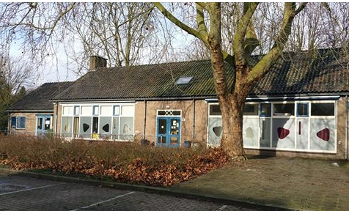

2. 2020: OWN PLACE WITH MANY NEW ACTIVITIES AND WIER OPENING HOURS

2020 A good start to Our DREAM at Meidoornlaan 18a
After the Christmas brunch in the living room, the year 2020 started so gloriously with the meetings at our own Our DREAM hideaway, Meidoornlaan 18a in Brummen, where we were given space for all our different activities. The furnishing of the various spaces was a feast, during which we managed to find a lot of things for free or for next to nothing.
In the week before the opening, three-phase electricity was installed and the beautiful oven, which we were able to purchase from the Liveability subsidy of the province of Gelderland, was installed, so that after the official opening we could start cooking and baking and we could enjoy warm meals together. food. January and February were the start-up days and after the opening we were going to have a blast. Finally really working out our plan and ideas.

Opening Meidoornlaan 18a
On 20-02-2020 at 02.20 in the afternoon was the official opening of our own accommodation.
The visitors unpacked the flag, after which the St. Onze DROOM flag was officially hoisted by mayor of Hedel, alderman van Ooijen and our chairperson Sonja Leemkuil.
That could be riveted and feasted on. What a joy and what an interest in the opening and Our DREAM. The opening was attended by many, about 150 people, and we received many congratulations, flowers and treats. We received a check from the visitors and a nice banner and a check for 860 euros from the Lions Brummen. Four students from Het Rhedens College in Dieren provided the catering.

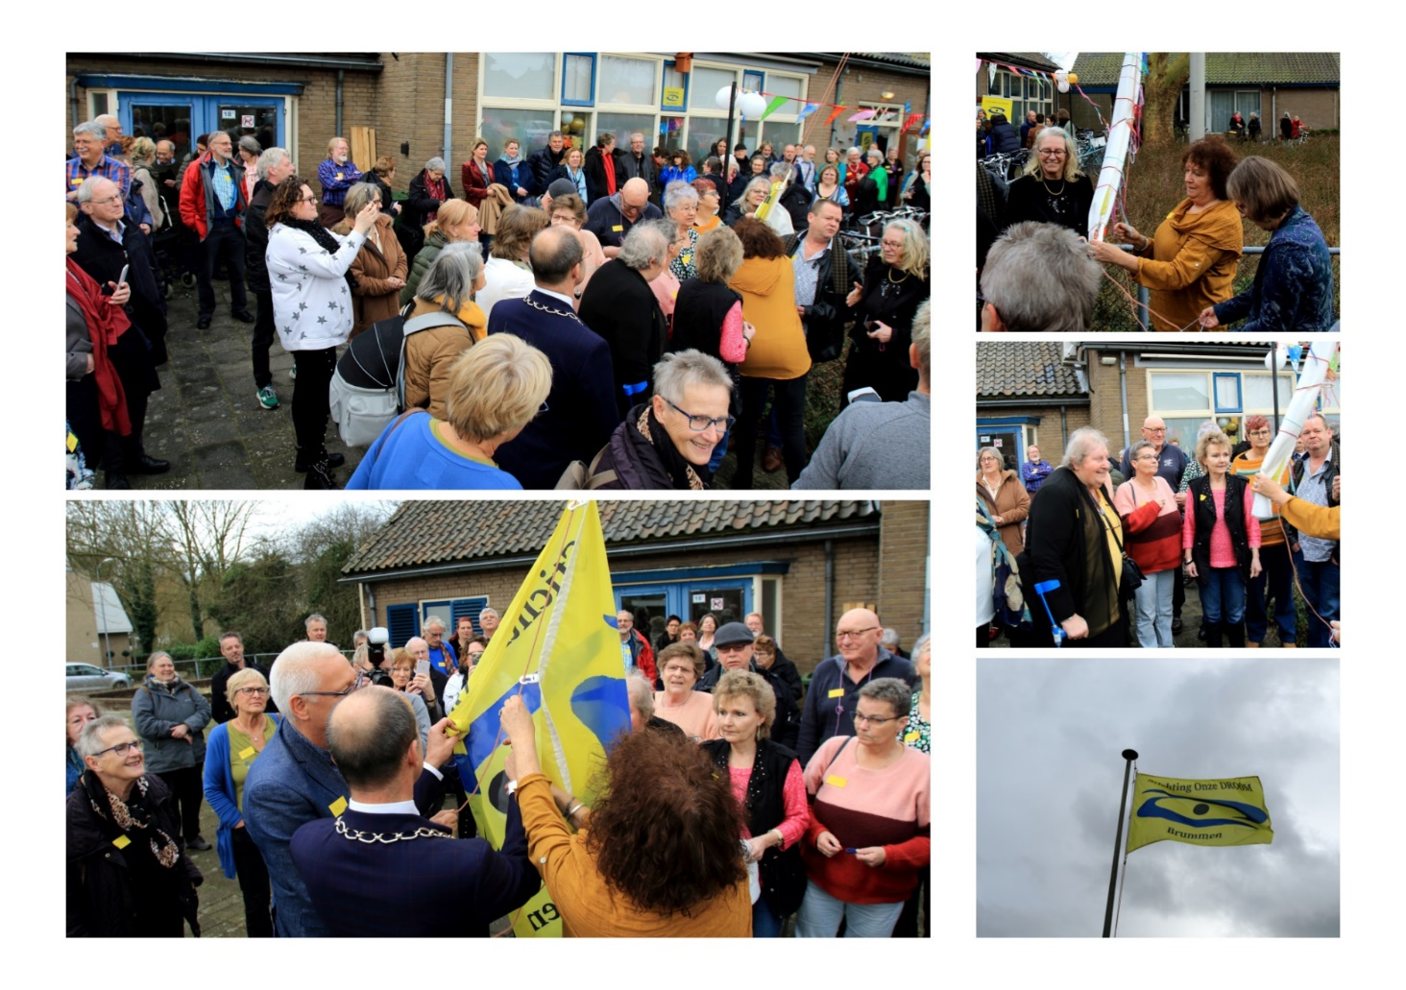

The construction of the garden
Thanks to neighbours, volunteers and visitors, the construction of the garden has fortunately got off the ground, despite the corona measures in 2020.
Tiles were removed and flower boxes were made from the many tiles. The NL Doet day could not go on and that is why neighbours, volunteers and visitors helped in stages to put the garden soil in the containers.
The flower garden was made colorful and the strawberry plants and fruit bushes and mini fruit trees were planted as well as the vegetable plants in the vegetable box, the former sandbox. Our thanks to Gerrit is great, he has provided the plants with water almost daily in these warm summer months. Due to the good care, it was already possible to harvest in the summer months.
We harvested and ate strawberries, red currants, courgettes, beets, radishes, pumpkins, lettuce, herbs from our own garden. Even the mini apple tree gave us 1 apple.

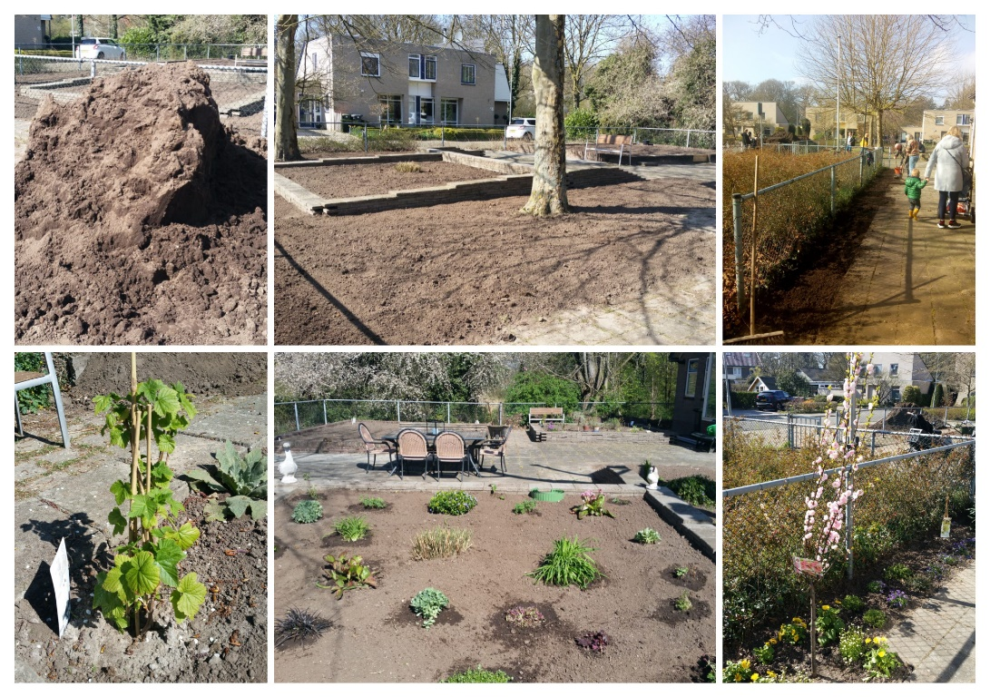

Hot meals
Now we could open and organize what and when we wanted and it was possible, in addition to the set lunch on Thursday, to eat a hot meal together with fresh vegetables from our own garden on a number of days. With a number of visitors we ate on Tuesday afternoon and Wednesday evening and twice a month at the weekend: once on Saturday and once on Sunday.
Our barbecues on Saturday were also very popular. Many visitors, who are alone no longer barbecue and others had never barbecued before.

visitors
Although we have been open very limited due to the corona pandemic, the number of regular visitors has grown. Just like the people, who occasionally come to drink a cup of coffee or tea and have a chat and/or participate in an activity.
The freedom to come and go as one pleases is very pleasant for many. But some people come in the morning or afternoon or stay all day.
Satisfied they then go home and say until the next time. We often hear how glad I am that you are here, if I didn't have you then I wouldn't have to.

Volunteers
We can rely on our regular volunteers:
- for the clothing issue
- for taking care of coffee / tea and lunch
- for preparing the meals
- for taking care of the garden
- for the Repair Café
- for our activities, such as music, painting and being creative
- and our visitors are (if possible) volunteers

Contributions
The contributions for coffee, tea, lunches, meals and activities such as flower arranging and painting are kept as low as possible so that people with a low income can also participate. A personal contribution is requested to cover the expenses and also for the self-esteem of the visitors. Where possible, everyone helps by bringing a pack of coffee, treating them to cookies or a homemade cake.

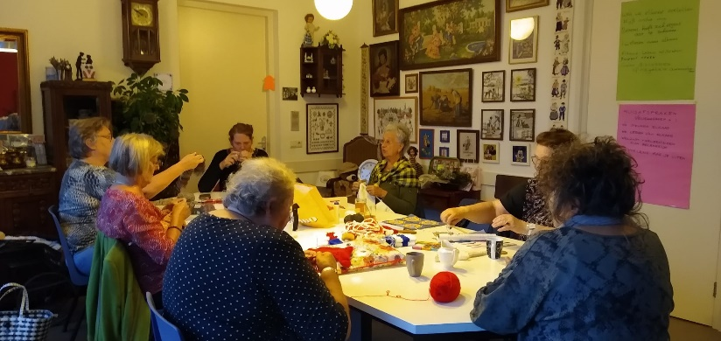
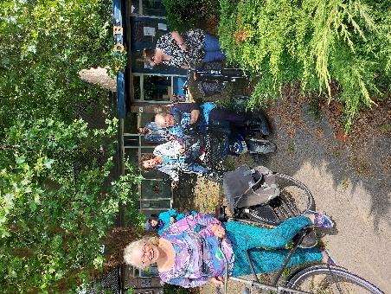
Contacts with visitors
The year started so beautifully and festively……… it was so difficult in March 2020 to May 2020 and November until the end of the year when we had to close our doors due to the corona pandemic. And...... that our hideout might already be sold this summer.
We had to look for other ways to maintain contact with our visitors. During this period, two of our three board members became ill.

Thanks in part to our volunteers, we have always kept in touch with our visitors, by telephone and also regularly made short visits to the door to bring cards, soup, delicacies, treats, an Easter piece and at Christmas a Christmas tray with a treat. The visitors and volunteers missed the meetings with each other and us.

There are also various (telephone) contacts.
And despite the contact moments, it is distressing to see how some of our visitors became more isolated again during the lockdown and their well-being has deteriorated during that period.

In May 2020 Sonja turned 65 and the visitors and volunteers were able to congratulate her one by one from a safe distance outside. All this accompanied by guitar music and singing by our Joop. What a surprise this was for Sonja, because of this she was able to enjoy her birthday and beautiful gifts.

We are also a kind of carers for a number of visitors during this time. Everyone could always turn to Sonja for good advice and help with money worries. Now we did errands for various people, took them to the hospital, were there for them after they came home from hospitalization, etc.

Open again: from June to November 2020
In the month of June we were allowed to get together again, something was possible again and we mainly came together outside (remotely). So wonderful that the sun shone a lot on the meeting days. With enough distance it was possible to sit outside with fifteen to twenty people. Inside, we can receive nine people by dividing the visitors over two rooms.

There was a meeting on Tuesday and Thursday morning and a growing group of visitors took advantage of this. Thursday afternoon there were activities, playing games, flower arranging, painting, music, etc. The clothing issue weekly on Wednesday morning and the Repair Café monthly on Thursday morning and by appointment.

To celebrate that we could open again, although limited, we organized a cozy barbecue for our visitors in the summer of 2020. It was a festive gathering. Of which 22 people at a time feasted, and many had tasted roasted sweet chestnuts for the first time, and had a nice chat with each other. Together at a safe distance and just having fun together.

In the summer we organized two fashion shows outside with clothing from our Clothing Issue. Various visitors and volunteers showed the clothing.
The whole was graced by a special guest, who, each time beautifully in style, grew older and older. First a girl, then a mother, and finally an older woman.
During the second fashion show, Marita's daughter and granddaughter walked along, so that children's clothing and clothing for young people could also be shown.
Both shows attracted a number of regular visitors and interested parties.

Closed again
In November we had to close our doors again and fall back on the previously devised ways of maintaining contact. With Sinterklaas and Christmas everyone was surprised with something delicious.
Marita has interviewed a number of visitors during this time and two booklets have been made of this, which have been distributed among the visitors and other interested parties. The interview was a short description of the life course, how Our DREAM is experienced and how the corona time was experienced. This way the visitors could get to know each other a little better.

Visitor numbers:
There are an average of 8-12 unique visitors to the Meeting per half-day.
Outside we could be together with 16-18 visitors.

In 2020 we had a total of 660 meetings 239 lunches 198 activities 61 hot meals
72 clothing issues 49 Repair, total 1275

In 2021 we had 769 meetings 342 lunches 224 activities 92 hot meals
120 Knitting Crochet Club 108 clothing 52 Repair, total 1378
3. 2021: OPEN AND CLOSED, EXPANDING ACTIVITIES AND PARTY

Goodbye
Paula: In January 2021 we had to say goodbye to Paula, our visitor from the very beginning. First from her house on Meidoornlaan and later from Tolzicht, where she lived after hospitalization and rehabilitation after a fall from the stairs.
We enjoyed Paula, her wisdom, her smile, her creativity and how she walked stately upright behind her walker and she always came back with some picked up waste in her walker basket after a walk in the park. The painting that Paula painted at Onze DROOM was used for the image on her farewell card.

Aartje: In the summer of 2021 we said goodbye to one of our most loyal guests: Aartje. Since 2016, Aartje has been a regular visitor on 3 half-days a week, previously she went to the day care center in Philadelphia.
Aartje's compliment will always stay with us and is still heartwarming:
"With you I don't feel like a patient, with you I feel like a human being, you are my family". She moved to Spain with her partner Harry. Aartje has received a beautiful page from each of us as a reminder. She is still in regular contact.

Sonja knighted as Knight in the Order of Orange-Nassau
At the initiative of the chairman of EAPN - Netherlands (European Anti-Poverty Network) and the MAR municipality of Brummen (Social Advisory Council) a ribbon has been requested for Sonja. On April 30, 2021, Sonja was the only one in the municipality of Brummen to receive the honorable title "Ridder in the Order of Orange-Nassau". She is rewarded with this award for her unwavering commitment to people who are stranded. It gives people in poverty and exclusion a voice, even at an international level through the European Anti-Poverty Network (EAPN). She also founded and designed the Onze DROOM Foundation. Due to all the corona measures, the mayor of Hedel came to bring the knighthood and it was pinned by Gerrit, her husband. The knights' party owes Sonja.

Open again
Fortunately, this lockdown also came to an end and the weather gods were kind to us again, so that we could meet outside with a little more people, remotely.
This was put to good use and new guests could also be welcomed.

Our DREAM started with the Knit & Crochet Club on Tuesday night led by Willie. This was immediately a great success. Some people learned to knit socks, others brought their own crafts with them. Many tips were exchanged. It's fun and there's a lot of laughter. Later in the year, when the curfew was imposed, this evening was moved to the afternoon.

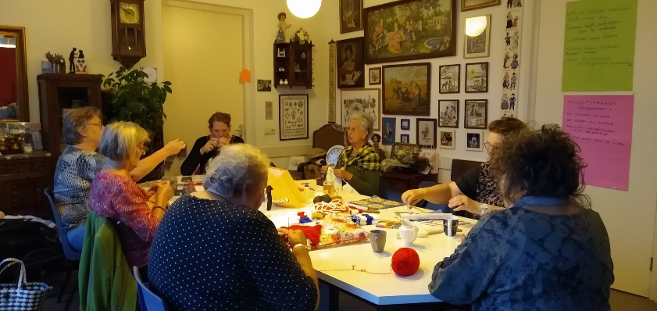

Every Wednesday morning, all residents of Brummen could participate in sports/move for free at their own pace and strength, led by sports coach Thijmen-Jan and trainee Rosa van Sportkompas. About six to ten people made use of this. Movement exercises were done and sometimes a game, there was walking. In the summer, a group rode their bicycles and scooters to the church in Hall and were treated to a guided tour with an organ concert. Afterwards there was time for a cup of coffee/tea and a chat.

At the end of September 2021 we organized a neighborhood coffee/tea and barbecue . A number of neighbors went for coffee and had a nice chat with the visitors.
After the nice BBQ Sonja took the floor to thank everyone for the pleasant hours.
She had less positive news about her health and asked the visitors to look to the future with her positively and confidently .

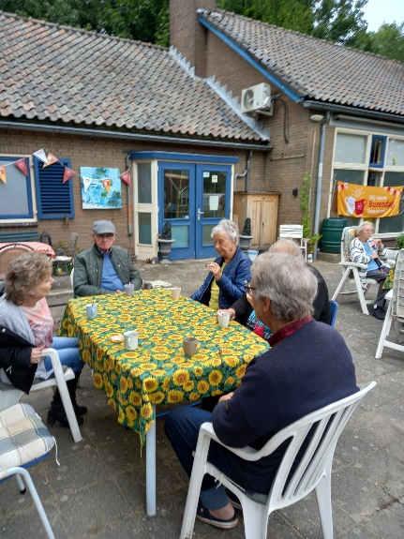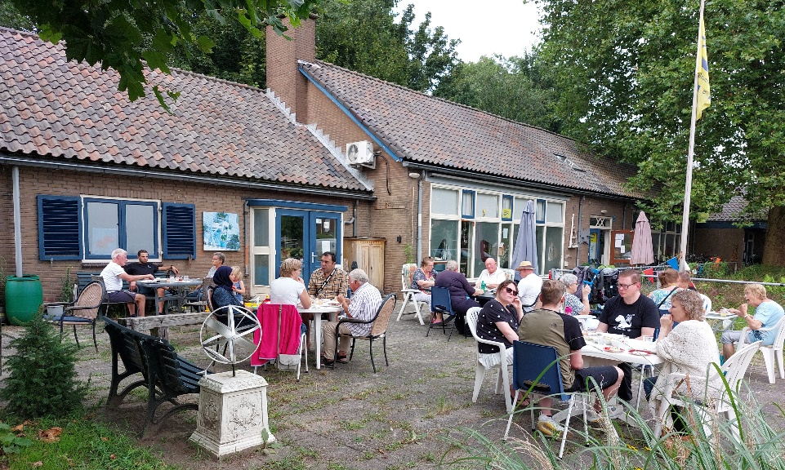

Lift your Life
Two Lift je Leven courses were launched in September, in which a fixed group of people work on a sustainable lifestyle in twelve meetings, with a focus on 'good with money', 'good with health' and 'good with greenery'. More about this later in this report.

First lustrum Our DREAM Foundation.
Our DREAM existed 5 years on January 5, 2021. Due to the lockdown, we couldn't celebrate this on January 5th. Fortunately, that was possible on November 3, 2021 and we were able to celebrate our "first lustrum at Meidoornlaan" at Meidoornlaan 18a.
We are so proud that our efforts and perseverance have made this possible!
And how happy Our DREAM visitors are that we exist!

4. INTERNSHIP AND WORK EXPERIENCE PLACES
Students of the Rhedens College helped with the opening on February 20, 2020 as part of their social internship. A group of students also came to an internship on location at Onze DROOM to spoil our visitors with hand care and nail polish. And we were invited to Het Rhedens in Dieren for dinner and we had a delicious meal in the restaurant of their school.

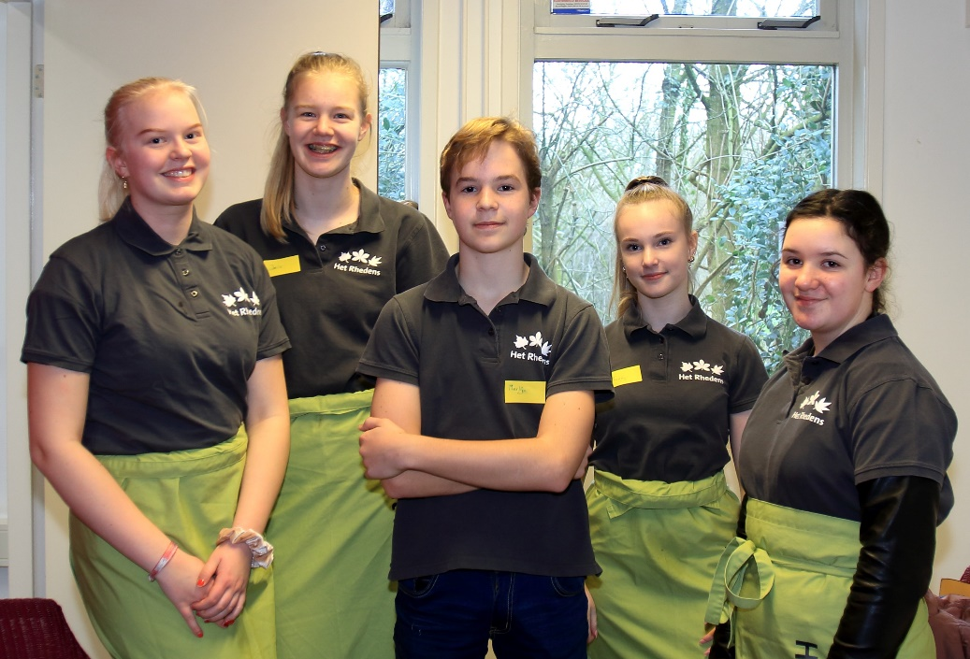

The opportunity to gain work experience with us remains. There is always enough work in the garden and in the maintenance of the property. Even if there are no visitors.

We had a regular help from Tactus/Riwis/Buiten de Veste , who did a lot of work.
He has moved on to another workplace, but remains one of our regular visitors.
either in the kitchen, the living room or in the garden. Someone has also been through Humanitas for a number of months to help in the garden. Unfortunately, his health deteriorated and he had to stop working for us and now works closer to home in Eefde. There is still telephone contact.

WerkFit A good collaboration has developed with the WerkFit coordinator and customer managers. For example, a volunteer has joined Onze DROOM, who helps with the meetings by serving coffee and preparing a delicious meal, so that she can practice and improve her Dutch language. Two participants took part in the Lift your Life Program via WerkFit. Residents from WerkFit will also participate in the Lift je Leven Program 2022.

5. CIRCULAR ACTIVITIES IN THE CONTEXT OF SUSTAINABILITY
Repair Café Brummen for the repair of clothing/textiles and the repair of defective (electrical) articles, such as vacuum cleaners, coffee machines, etc. Stimulating the reuse of materials and ensuring that materials are reused at third parties, by making young and old aware together reuse/repair/repair of items.
The Repair Café Brummen has been limited open due to the Corona lockdown / measures. Even so, 60 repairs were carried out. If there were defective vacuum cleaners or coffee machines, they were repaired at home by the Repair volunteers. Clothes were also repaired at home.
That is how we remained sustainable.

Clothing issue
Our clothing issue remains necessary. By appointment we could continue to provide clothing/footwear and help people with bed linen, towels and tea towels, and so on.
About 70 people have used it. A lot of clothing, footwear, bedding and toys have been issued.

At the beginning of 2020 we had to vacate the former RABO building, where our weekly clothing distribution had taken place until then. We are very grateful to the Teunissen family for giving us more than a year the opportunity to build up our clothing distribution.
At Meidoornlaan 18a, a permanent space has been set up for the distribution of clothing. We received a contribution from the parishioner PKN Brummen for the racks and clothes racks.
We receive clothing and footwear, etc. from Solluna and residents. When the seasons change, the remaining clothing goes to St. Dorcas.
Until February 2021, we could use the garage of the former Bouwvereniging Brummen on Kampweg for the storage of summer/winter clothing and other issue materials. We are very happy that Veluwonen wanted to help us in this way. Due to the sale of the property, we had to move the clothing storage to Meidoornlaan.

Recycling and reuse of materials
We save various materials that can be recycled and the proceeds of which are intended for charities. In this way we create more awareness among residents and visitors and for the environment. That's how it goes
- the seasonal clothing/footwear and textiles to St. Dorcas
- the baby clothes to St. Baby Stuff, so that we work together to reduce the effects of poverty on babies and young children. St. Babyspullen provides packages for free through various agencies to (future) parents in the Netherlands who are having a financial hard time
- Knitted/warm scarves and hats and crochet bedspreads to children's homes in Central Europe. Incontinence materials, which would otherwise be destroyed in the Netherlands, are sent to Bulgaria/Central Europe via a married couple in Vorden
- Wool remnants to St. Consolation Blanket and Dorcas
- Plastic caps for the KNGF Royal Dutch Disabled Fund, for the training of guide dogs. Visitors and residents, as well as the students of Kindcentrum 't P@rk, have been saving with us for years. The caps are sorted and cleaned by our visitors
- discarded mobile phones to St. Opkikker
Then we are still sustainable by collecting:
- Collect batteries, inkjets, beer caps and metal lids
- Re-use of clothing/fabrics Old clothing is used to make bags and pillows, among other things.

6. FINANCE

Donors / Friends of our DREAM
In 2020 we received a nice donation from Joop Verhaar.
He has cycled many thousands of kilometers and sought sponsors for his cycling kilometers.
We received a nice banner from the Lions Brummen and a check for 860 euros.
In 2021 we received 1,000 euros from an anonymous donor.
For example, we have received donations from friends of Onze DROOM who support us and there are visitors who knit and crochet and sell their cuddly toys or knitwear and donate the proceeds to Onze DROOM.

Sponsor contributions of Joop's Bicycle Tour in 2020
Donations from residents who wish to remain anonymous
Donations Deka - baker Teeselink – Bas Jansen fruit and vegetables
Donations of creative knits and cards through visitor contributions
Donation from the Lions Club Brummen in 2020
Donations from the parish of PKN Brummen

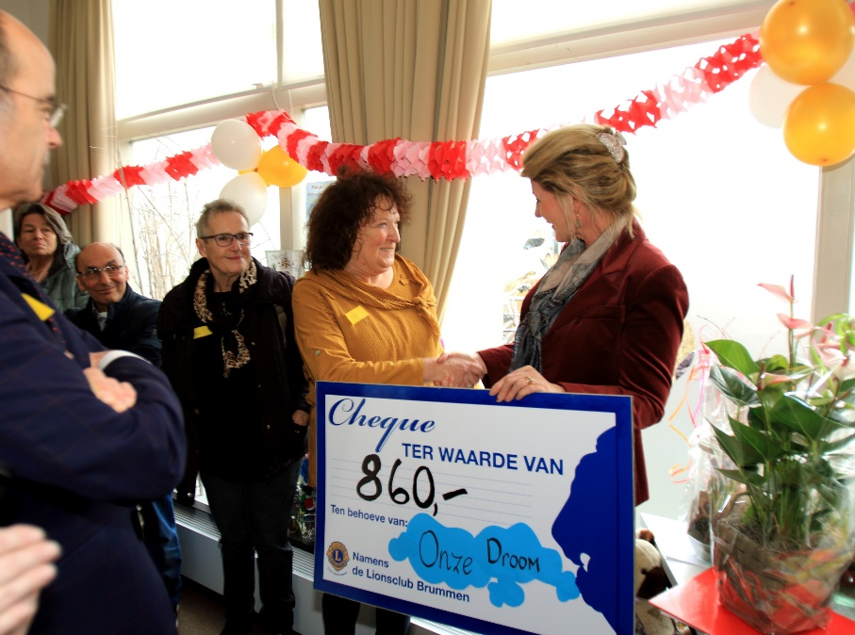

December promotion:
In the week of 20 to 24 December 2021, there was an old metal sponsorship campaign at Steenbergen Metaal Recycling in Brummen. We are delighted that such a young entrepreneur who has his company in Brummen, has such a warm heart for Our DREAM. In 2022 we will know what the yield is.

We thank all donors for their financial contribution

7. CONSULTATION AND COOPERATION PARTNERS
We work together with many organizations and we invest a lot of time and energy in this, but that also yields a lot of benefits for all parties. A random summary:
- Brummen Library
- Deaconie PKN Brummen
- EAPN Netherlands
- Reminder Point
- Municipality of Brummen
- Child center 't P@rk
- Node Informal Care Brummen
- Quality of life alliance province of Gelderland
- LSA National Partnership Active Residents
- Making place The Villa
- Restaurant de Korenmolen
- Rhedens College
- RIWIS
- Solluna
- Spectrum (partner with Elan)
- Foundation Welfare Brummen
- Elevator Foundation
- Tactus
- Veluwonen
- WorkFit
- the Wildbaan

Prevention agreement Healthy together in the municipality of Brummen
We are joining forces with the prevention agreement. Together we are working on a healthier municipality. We do this by implementing concrete actions linked to 3 jointly defined themes: healthy growing up, healthy workplace and healthy ageing.
St. Onze DROOM has co-signed the prevention agreement Healthy Together in the municipality of Brummen and Sonja participates in the working group on behalf of St. Onze DROOM.
Our ambition: healthy together! We strive for a healthier municipality and do this together with our residents. We look at health in a broad sense. What creates resilience and what makes life meaningful? We bet on that. Because if we can keep doing what we think is important, we stay healthier. This means that we not only look at physical health, but also at aspects such as meaning, participation and quality of life.

Summer conference “Small Resistance, Great Happiness” Liveability Alliance Gelderland
On October 11, 2021, Onze DROOM took part in the market of the Summer Congress “Small Resistance, Great Happiness” at the Honig complex in Nijmegen with approximately 300 conference attendees, organized by the Liveability Alliance Gelderland , with inspiring speakers, workshops, a Waarmaakplaats and speed dates and funds and organizations.
By boosting “Our DREAM” knowledge and our network, we, together with other organizations, make the Liveability Movement in Gelderland bigger by being an example for initiators.

We hear big words (more than) enough through the media and social networks. It is particularly inspiring to see, together with other citizens' initiatives, how we can use our activities to set in motion a movement that cannot be reversed. With creative go-getters, who go for an ideal, we can exert great strength together. Our experience is that we want to belong to this quality of life movement and continue to contribute . †
Not growth and money as the leading pursuit, but commitment and happiness . Not wanting to change the world all at once, but taking small steps; cycling with a small resistance. Out of conviction and/or necessity, dare to organize society differently, with giving, sharing and cooperation as the starting point.

The GelderlandTour
The GelderlandTour Brummen was organized in collaboration with Sonja Leemkuil of the residents' initiative Onze DROOM, on September 14, 2021 in the parking lot at Onze DROOM.
An initiative of the Liveability Alliance Gelderland, in which we jointly investigated the impact of Covid-19 on our local social structures. We did this by first talking to Ontmoeting Onze DROOM visitors and a few residents. After that, we entered into a conversation with various representatives of organizations (Library, Village Council Brummen, SWB, Maakplaats The Villa, Social Domain official Brummen Municipality, Social Advice Council Brummen, RIWIS and St. Onze DROOM), based on a Viability Alliance developed program. The topics discussed were “What did residents miss or what not at all? What do they need now, to reconnect with the people in their living environment? And how can we as a Livability Alliance possibly contribute to this?”

Collaboration of the parish of PKN Brummen. We received a donation from the deacon to buy clothes racks and cupboards. For example, they involve us and the sustainability of used clothing and toys in their campaigns by giving Vouchers for the Holiday Packages for children who cannot go on holiday and vouchers for a promotion for something extra for the minimum wage.

Lift your Life. The Project Plan Stichting Onze DROOM "Lift your life" has been submitted to the municipality and an innovation subsidy has been applied for, and the subsidy was awarded in 2021. For example, two board members were able to follow the training to become a coach at St. Lift, in order to offer the Lift your Life program free of charge to 36 residents. Participants are encouraged in twelve meetings to take steps towards a sustainable lifestyle. “handling money well”, “handling greenery well” (environment) and “handling health and happiness well”.
In 2021, the first 10 participants successfully participated in the Lift your Life Program and received the certificate of participation in December 2021 from Alderman Sjerps. In 2022 we will start with new groups.

Workshop Lift your Life at Korak in Apeldoorn
After meeting Driesje van Korak Apeldoorn at Onze DROOM, to discuss the possibilities for collaboration, we held a Lift je Leven workshop at Korak in Apeldoorn in August 2021.
There is a lot of interest in a Lift your Life Program among Korak participants. We have decided that this is possible in Brummen, after Onze DROOM has met the conditions of the Innovation subsidy of the municipality of Brummen.

study days
The board members of St. Onze DROOM follow various information meetings online about Loneliness, Experiential Knowledge, Self-Help Networks, etc.
Two board members have followed the training to become a coach at St .Lift.

8. HOUSING

We are very happy with our current, albeit temporary, accommodation. Here we can work out some of our plans and demonstrate that there is a great need for low-threshold encounters and gatherings. And, despite the confusing time, we succeeded.

Your own place What started so beautifully.....
Unfortunately, the course of events surrounding the sale of Meidoornlaan cost us a lot of energy and visitors do not understand that they have not been awarded a location. first a number of visitors had to leave at 't Trefpunt and now again at Onze DROOM?

The sword of Damocles, however, lingers over our heads. Plans are being developed for housing for elderly people with dementia on the Meidoornlaan 18a/b plot by Daily Life, together with the municipality. Even though we knew it was a temporary location, we really didn't expect so much uncertainty and setback.

Together with Caspar Altena of the Wildbaan, we sat around the table a number of times to see if we could do something for each other. Caspar planned to buy Meidoornlaan 18a/b and then, together with the shelter for young adult people with disabilities, offer space to Onze DROOM. Due to the plans of Daily Life, this plan has been put on hold. However, we continue to talk.

In 2021 we have been constantly looking for contacts who can help/support us in our search for a permanent location. Many possibilities have been explored and often dropped because they turned out to be unfeasible.

We sat down several times with the municipality, alderman Sjerps, civil servants Terlingen and Jongbloed to discuss our housing, including once in April 2021 with alderman van Burgsteden.
Our preference is for a location in the center of the village. There are various options, which are met with objections time and again.

A concerned resident, who has good intentions for us, is in discussion with the municipality about purchasing a property in the neighbourhood. This resident wants to reserve a space for us in this building.
We have close contacts with a sports association with its own space and a care institution that has space available. A major drawback of both locations is that they are far from the center for a number of regular visitors.
To date, all these efforts have not led to a definitive result.
Councilor Wijnhoven is preparing an initiative proposal, in which attention is paid to and asked for our housing problem.

Despite everything, we keep our spirits up and we sincerely hope that Our DREAM will be given a permanent place to further expand our work. Our DREAM has been active for six years and has certainly proven its right to exist and deserves to get a location for its visitors and volunteers.

9. POVERTY REDUCTION ACTIVITIES

Becoming visible- October 17- International World Poverty Day United Nations
^{the} 4th consecutive year, we symbolically crossed the poverty line to draw attention to the annual United Nations International World Poverty Day and show solidarity with the poor.
(In 2019 we had a conference with 35 people. Unfortunately, this was not possible this year due to corona measures.

We also contributed to the list of names for the meals round for lonely people of the Korenmolen and others.

EAPN-PEP meeting
On 24 and 25 November 2021, the 19th annual European Meeting of People Experiencing Poverty (PEP) meeting of people experiencing poverty took place at the library in Brummen. The meeting was not possible at Onze DROOM, because we do not have an internet connection. A visitor and volunteer of Onze DROOM would participate, but unfortunately he was unable to participate due to corona complaints. Sonja, as an EAPN NL/EU volunteer, was aware of the matter and participated.
Volunteers from Onze DROOM provided the lunches and the Syrian dinner. The participants enjoyed the dinner made by our volunteer Taghrid, who is with us from WerkFit.
The PEP meeting is organized by the European Anti-Poverty Network (EAPN) with the support of the European Commission.

170 people experiencing poverty from 28 European countries prepared at national level this year for the online meeting with plenary sessions, combined with online interactive workshops and short symbolic/visibility actions on the topics Housing – Adequate minimum income – Good quality healthcare – Digitization and access to services such as internet and devices/digital technology and have shared their knowledge and experience with each other and with EU decision-makers in one.

The crisis has had serious consequences for people living in poverty. The meeting is a concrete opportunity for PEP to directly express their experiences, knowledge and recommendations in the context of a direct dialogue with key policy makers and politicians at EU level. This year's meeting was therefore, in the context of a forward-looking EU, to spotlight PEP's political priorities for rethinking and building a new future for Europe and its citizens.

MUP .
There has been contact with St. Poverty Fund for some time. Since December 2021, St. Our DREAM has a Menstrual Products Issue Point of St. Poverty Fund.
If you have to get by on a limited budget during the week, that money is spent on food and drink. But that money must also be used to buy care and hygiene products. This means that there is sometimes no money for sanitary towels or other products. Menstrual products should be available to every woman who needs them. The Poverty Fund therefore makes products available free of charge through local aid organizations and other accessible locations. We want to offer ourselves the choice to choose a product that suits them and that they find comfortable .

Christmas packages
We brought an atmospheric light and Christmas greetings to all visitors in 2021. Thanks to all residents who handed in the mood light vouchers to us.
The Vouchers from the Children's Clothing Fair Eerbeek from Tineke Hut's Christmas hampers, which are collected unused by the recipients in order to give unused vouchers to grandparent(s) with a low income, so that they can provide them with a gift for their grandchildren. to get a gift or item of clothing.
There was a Christmas present for all volunteers, offered by HipLeven from Eerbeek.

Oliebollen campaign / Food
Through the Buurt Kastje Brummen we got the name of a resident who wanted to bake oliebollen for people with a low income. We packed the 225 oliebollen together with the coordinator Brummen of St. Dierenfoodbank Brummen and volunteers from Onze DROOM handed them out to the inhabitants who use them and to the addresses of minima known to Onze DROOM.
We also received food from Buurt Kastje Brummen to make a Christmas package for a number of people we know who live on a minimum income or to use it for a meal at Onze DROOM.

Noaber help
For a visitor/volunteer with a small grant, we collected a linen and chest of drawers, lamps, etc. via the giveaway corner in 2021 and assembled the cupboards to make his room cozy. A walker for another visitor. For example, we make residents with a small budget happy with clothing, footwear, linen, toys, books, cutlery, etc.

Just before Christmas we were approached by the coordinator of the Money and Administration Center with the question whether we could do something for a gentleman who has been given a home in Brummen due to a divorce and medical problems.
After telephone contact and a visit to the new resident, we have, thanks to a social resident for transport, a dining area, TV cabinet, coffee maker, kettle, laundry basket, trash can, table lamps, a bed and bedding, crockery, cutlery, and hand / tea towels etc. can help, so that it became a cozy house. We also brought some games and a present for his son who came to visit after months.

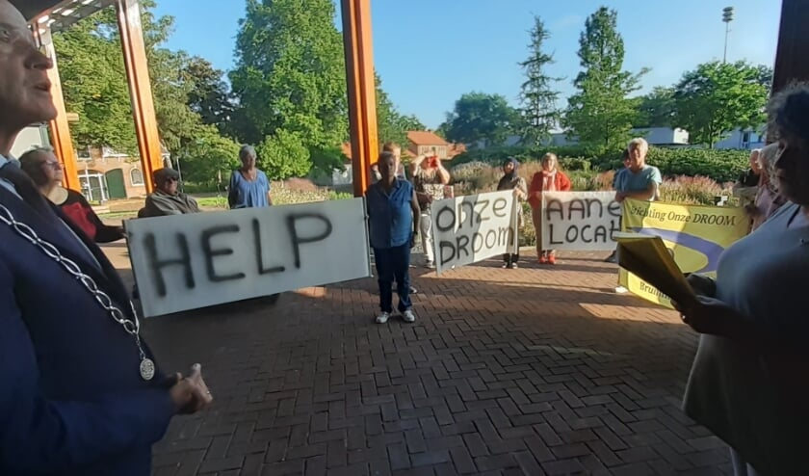

10. PUBLICITY

Social media and website
We share our program and activities on Facebook.
On the website you can find all activities and also the news about St. Onze DROOM

Media
Thanks to the local newspapers Brummens Nieuws and the Regiobode, de Stentor, we are regularly featured in the media. We try to bring as much positive news as possible.
Since we also draw attention to our housing, this is sometimes less positive, but a solution would again be placed positively.

Our DREAM in the Dragonfly
Libelle Carlijn Simons wrote: A little more COMPASSION please , that makes everyone better
Compassion for others can again result in a simple being for each other, as in Brummen in Gelderland. “With St. Onze DROOM we created a meeting place for everyone who needs company and a listening ear”, says initiator Sonja. “As a result, people who got to know each other here over a cup of coffee, a meal or an activity now go to the hospital together or run errands for each other. How well such contact works, became apparent during corona. Everyone was so happy to see each other when we were allowed to open!”
Connecting with others makes us feel seen as human beings.

PETITION HELP OURDREAM FIND A LOCATION
BRUMMEN - With this slogan on three banners, the visitors and the board of the Onze DROOM Foundation handed over the 432 signatures to the mayor of Hedel on September 3, 2021. Within a week, 269 signatures were collected by visitors to Onze DROOM in their area and 163 online with support from all over the country.
The signatures were placed under a petition that read: “We would like to continue to exist! Do you think that Our DREAM is a household name in Brummen and do you think that our visitors and residents of the municipality of Brummen, especially those with a low income and who are lonely - more- participate, be together, be creative, eat together and can stay longer? enjoy being together at the citizens' initiative Our DREAM? Then help us to make it clear to the municipal executive and the city council that a truly accessible citizens' initiative can only continue to exist with financial support and a location from the municipality of Brummen.”
Sonja Leemkuil, the chairman of Onze DROOM, who was knighted in April, presented the signatures. In the words: “The added value of Our DREAM is that we, as citizens and residents of the municipality of Brummen, share joys and sorrows for, through and with each other and are ready to help each other where possible.” Our DREAM is maintained entirely by citizens, who all do this on a voluntary basis.
Mayor of Hedel promised to convey the petition with verve to the city council and the college. He is a big fan of Our DREAM and recalled that "dreams should not be deceit."
Omroep Gelderland interviewed a number of visitors and Sonja Leemkuil at Onze DROOM on 1 September and put this on its website.

11. FINALLY

2020/2021 will go down in history as the global pandemic that turned our lives upside down. This also applies to Onze DROOM and its visitors, volunteers, board and other stakeholders.
For all of us, in the months after the opening, there was still a lot of worry about the difficulties about the sale of the property and our own hideaway.

Our DREAM Foundation still has many plans. In addition to the meetings, the creative activities, afternoons with flower arranging, handicrafts, painting, music, the joint lunches and hot meals, the Clothing issue, the Repair Café Brummen and the Lift je Leven Program, we are 100% committed to the survival of all our activities and search for a suitable location for Our DREAM. This means that the move to a new location will take place in 2022.

We would like to thank all our visitors, donors, sponsors, residents, organizations locally, regionally and nationally and everyone who gives us a warm heart in any way for the contribution(s), the cooperation and the trust in us.

Despite all the uncertainty about our location, we keep courage. We look forward to 2022 with confidence and positiveness and hope to move to our own permanent location.
We deserve a place of our own and certainly Our DREAM visitors in the year 2022.
We certainly showed what we mean to each other!
On January 5, 2022 will be our 6th anniversary!

We hope to see you all in good health often in 2022.
Be welcome. The coffee/tea is ready!

